Project Group 8 - Project 1 – Air Pollution: Particulate Matter

The focus of this report is to elucidate how fine, airborne, particulate matter is measured by industry and regulators to provide for cleaner air. This matter, in the air is referred to as “aerosols”. The modeling of such concentrations using functions and integrals will be presented, along with the numerical computation of integrals related to aerosol regulation. The report answers questions from an information sheet and the answers have been divided into respective groups (the 1’s, 2’s and 3’s have been grouped together).
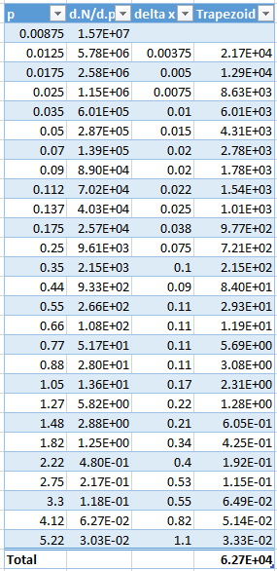
Aerosol particles are measured in a typical range of 10 angstroms to 100 microns. Due to the causal relationship of diameter to effects on health, diameter is used to group particles into different strata for measurement and analysis. The assumption is that they are spherical, where they are not they are taken to be equivalent to a spherical particle of the same volume. So, for a cubic particle, 1.2 microns on each side, having a volume of (1.2)^3 μm = 1.728 microns, it is taken to have a “diameter” of a spherical particle of the same volume which would have a true diameter of 1.48884118 μm.
The measurements in this range are taken in intervals, denoted as p, and the number of particles at that interval follows from a function N such that it is denoted as N(p). The derivative of this function is called the size distribution function ( $\frac{dN}{dp}$ ), and an integral of the form:
gives the accumulated rate of change of the number of particles N(p) from p1 to p2.

